**Functional Requirement Document for Car Washing Services – Justdial.com**

**Contents:**

1. Introduction 3
   1. Purpose 3
   2. Intended Audience 3
2. Functional Requirements 3
   1. Home Page 3
   2. Search 4
   3. Result Page 6
      1. Top Result 7

2.3.2 Popularity 7

2.3.3 Location7

**1. Introduction:**

The function requirement document is a complete description of the new feature of the webpage. This document also describes the user interaction and the response of the webpage.

**1.1 Purpose:**

The purpose of the document is to give the functional requirements for the ‘Car Washing Services’ in Justdial website. This document will help the audience to understand the behavior of the application for development.

**1.2 Intended Audience:**

* Development Team
* QA Team
* Business Analyst
* DB Team

**2. Functional Requirements:**

* When the user types the URL <http://www.justdial.com/> it should navigate to the Home page of **Justdial** website.

**2.1 Home Page:**

* The Home page should contain the following fields at top section:
* Free Listing
* We are Hiring
* What’s New
* Advertise
* Language dropdown
* Login/Signup

(Home page screen is shown in the **Figure 1.1)**

* Left frame consists of various associated options like Shop Online, Real Estate, B2B, Air Tickets, On Demand Services, Anything on Hire, Loans, Auto Care, Automobile,, etc
* Right frame currently consists of tabs for Customer Care & Free Listing
* Main page displays Search function in top. Below that other support services like Restaurants, Doctors, Real Estate, Shop Online, etc are provided.

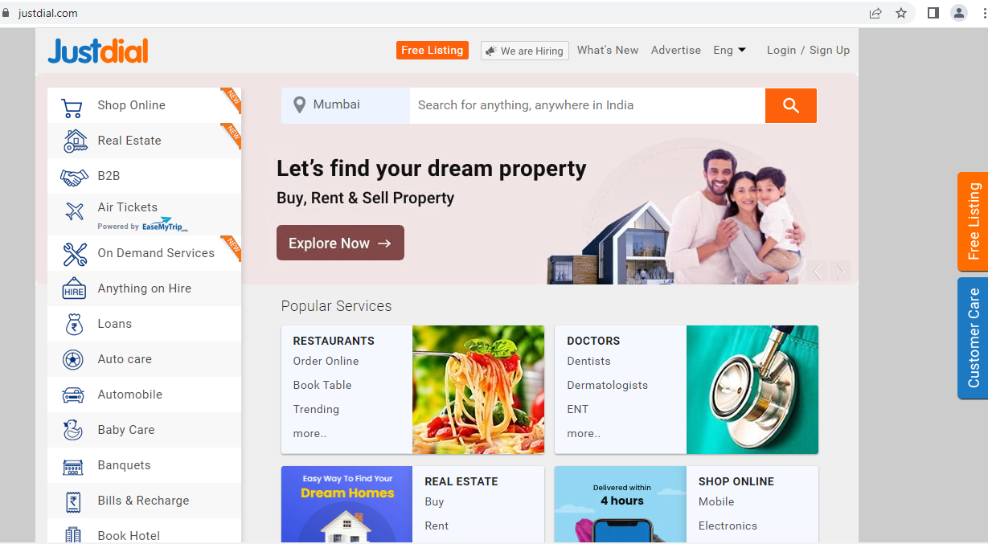  
 **Figure 1.1**

**2.2 Search:**

* A textbox **Location** is needed for Search operation, for user to type the Location / City. Alternatively, user may choose from the populated values in the suggestion drop box.

(Location textbox with its populated values in search looks like in the **Figure 2.1)**

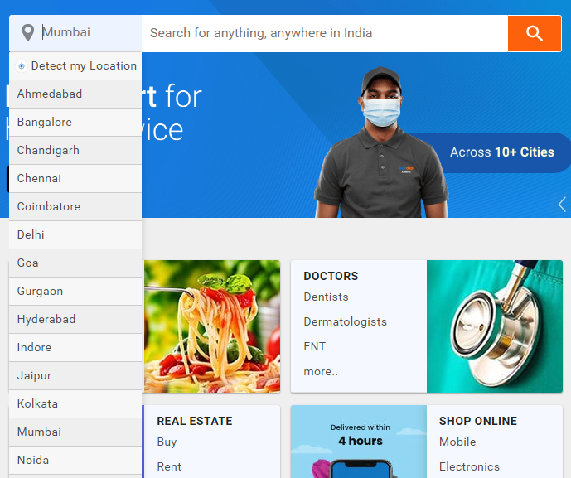

**Figure 2.1**

* A textbox Service is needed for Search operation, for user to type the services he would want to avail. Alternatively, user may choose from the populated values in the suggestion drop box. It will show a text “search for anything anywhere in India”

(Enter Area textbox with its populated values in search looks like in the **Figure 2.2)**

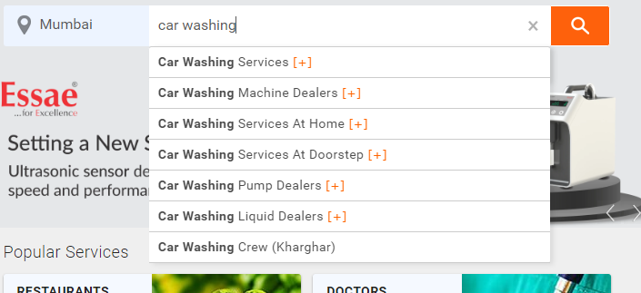

**Figure 2.2**

* A button is needed for search, on clicking will fetch the given services.
* Give a location & a service (example: Car Washing Services) and click the **search** button in the home page. This would populate the service offered in the given location with its details. If no such service available in given location, show message “No Services for this location”

(Refer in the **Figure 2.3)**

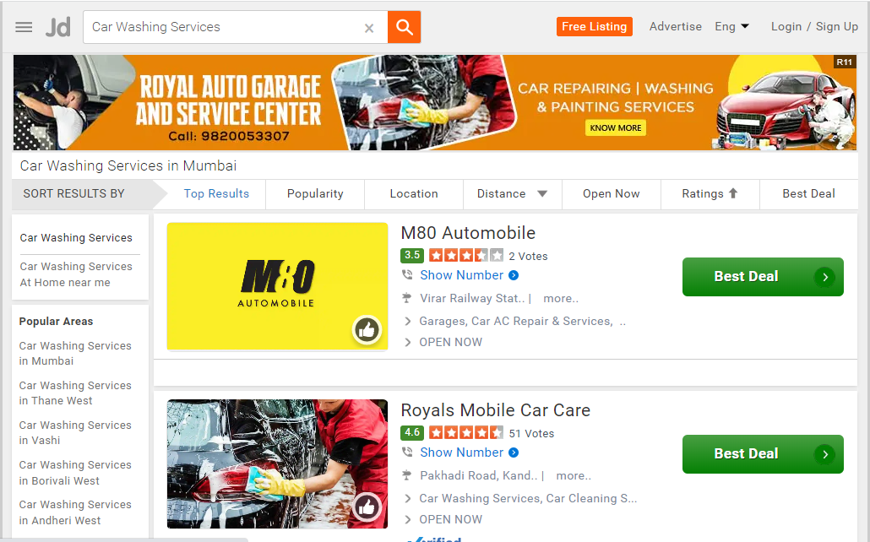

**Figure 2.3**

**2.3 Search Result:**

The search will produce a bunch of the business provided in the location randomly.

* Default sorting is by **Top Results.** (as in **Figure 2.4)**
* For each service populated below details are shown in the given order
* Name of the provider
* Rating in green box, stars and number of votes
* Phone number with code (click on ‘Show Number’ to view)
* Address
* Types of services offered
* Its current availability
* A green button for “Best Deal” on right side
* A picture of the provider on left side
* The result page offers various filters on top of search result as Menu tab. These filters are offered with a label **SORT RESULTS BY** and allows to choose the required filters (from below) to sort the results.
* Top Results
* Popularity
* Location
* Distance
* Open Now
* Ratings
* Best Deal

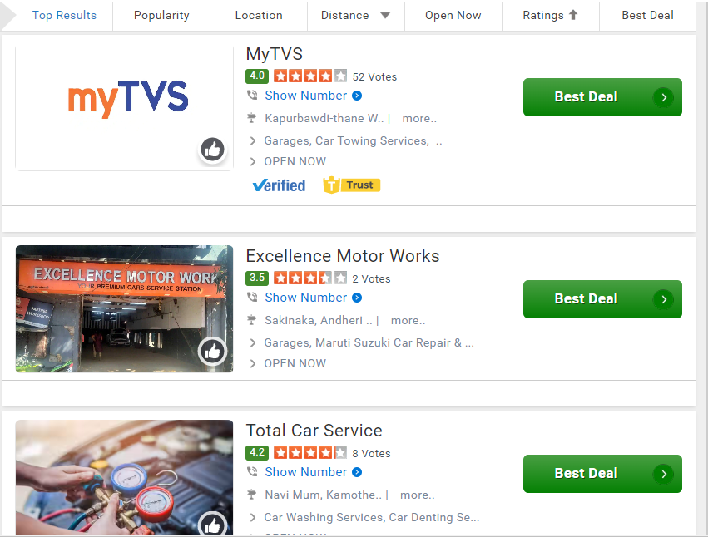

**Figure 2.4**

* + 1. **Top Results**

This will populate the services based on user rating & arranges in order from top rating. Rating is visible in small green box below the name of provider

* + 1. **Popularity**

This will apply a filter to arrange the services from most popular ones based on customer visits. (customer visits numbers not visible & go by feed)

* + 1. **Location**

Upon choosing this a pop-up appears with a text box. Type in any area within the city you picked up. This filter will populate only those services in specified area

* + 1. **Distance**

Clicking the dropdown button will give you the various distances ranging from <5Km, 5 to 10km, 10 to 25km, etc. Picking up each one will populate those services offered within the given range.

* + 1. **Open Now**

Filters & populates those services who are currently open for work. This is filtered based on the status “Open Now”

* + 1. **Ratings**

This filters based on number of stars with order from top stars

* + 1. **Best Deal**

This one filters based on best deals or offers provided by the services.